# Using a Python Script to Download Group Sets from Canvas

## First-time Setup

1. Download Python 3 from <https://www.anaconda.com/download/>.
   * It is available for Windows, macOS, and Linux. Make sure you download the **Python 3.X** (e.g. Python 3.7) version.
   * During the installation process, leave all settings as the default.
   * You do not need to install any of the additional software it may offer you during the installation process (i.e. VS Code).
   * Please note that the download may take up to 30 minutes. You can continue using your computer while the download is in progress.
2. Store the “GROUPS” folder provided by the CTL on your computer.
3. Open the folder and locate the *Canvas* cfg file. You will need to generate and paste your token here. You can open the file using any text editor, and you will paste your token on the lines that say TOKEN= after the equal (=) symbol. Instructions for generating your token can be found in this [official Canvas document](https://community.canvaslms.com/docs/DOC-10806-4214724194). When generating the token set the *Purpose* field to “CTL iClicker Registration Script” and leave the *Expires* field blank. Please note that this token is equivalent to your username and password. **Do not share it**.

## Required Data

Before you run the script you will need the following information for each of the sessions you’re checking:

1. Your course ID. This is a 2-5 digit number found at the end of the URL in your browser when you are on the home page of your Canvas course.

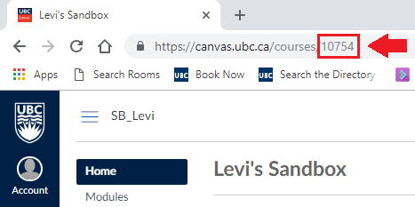

## Running the Script

**Please note that due to regular updates that occur in Canvas, this script may not always work. Contact us at** [**ctl.helpdesk@ubc.ca**](mailto:ctl.helpdesk@ubc.ca) **if you experience any issues.**

1. Open the **Anaconda Navigator** application on your computer (it was installed when you downloaded Python).

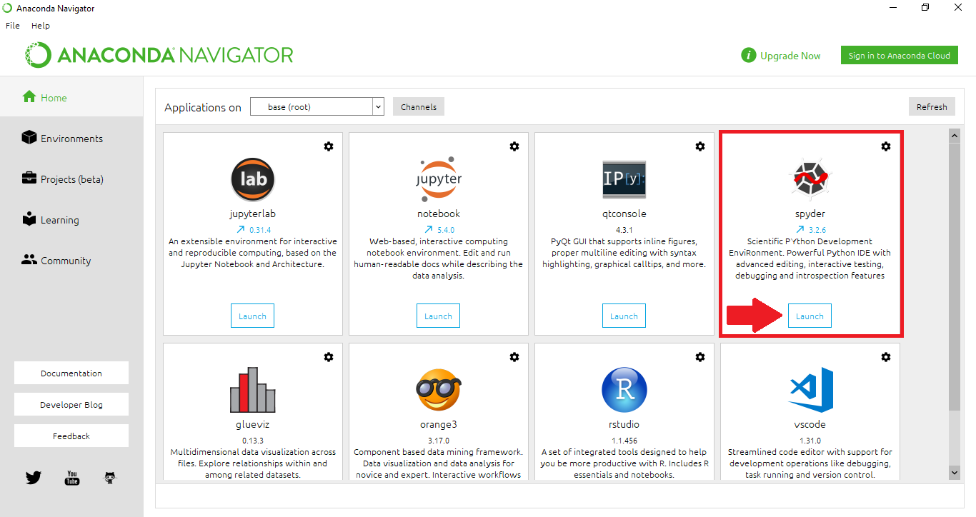

1. Launch the Python development environment, **Spyder**. It may take a few minutes to open.
   * You may get a pop-up indicating that Windows Firewall has blocked some features of Python. Allow access on both private and public networks.
   * You may get a pop-up informing you of available updates, you can close this.
2. Once Spyder opens, click on **File ->** **Open** and locate the *GROUPS* Python file in the “GROUPS” folder. Once you have opened this file, you can skip this step in the future as the file will already be open the next time you launch Spyder.

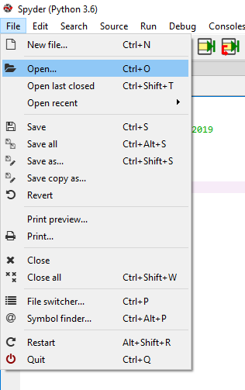

1. The code will open up in the left panel of Spyder (highlighted in red below). **Do not alter the code**. You will want to focus on the console window (highlighted in blue) which is where instructions will appear when you run the program. You can expand this panel.

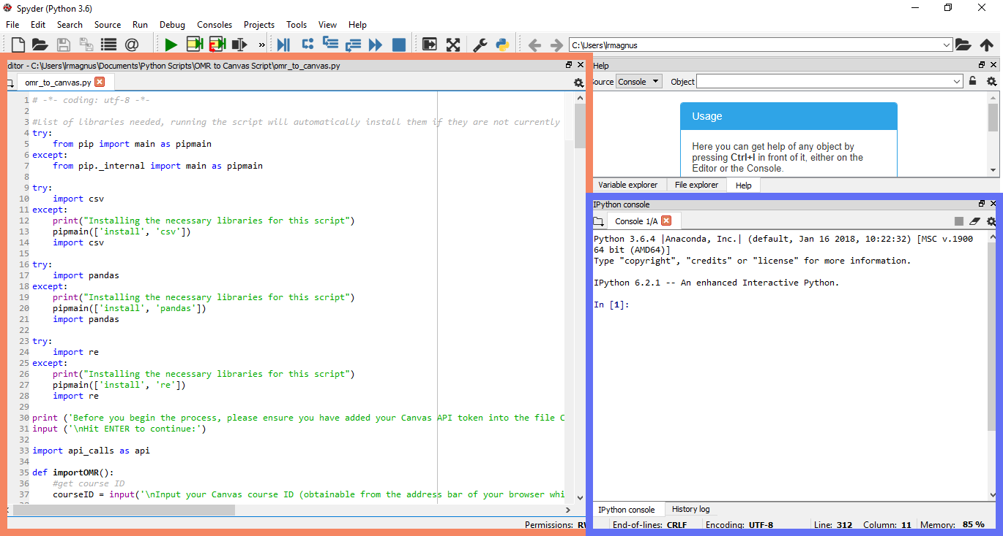

1. Click on the green triangle button in the toolbar to run the script. The script will open in the console window. Follow the instructions displayed in the window.

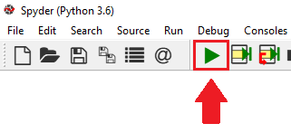

The first time you hit the run button a pop-up will appear asking you to set the runtime settings. Make sure under **Console** “Execute in current console” is selected and under **Working Directory settings** “The directory of the file being executed” is selected and then click **Run**.

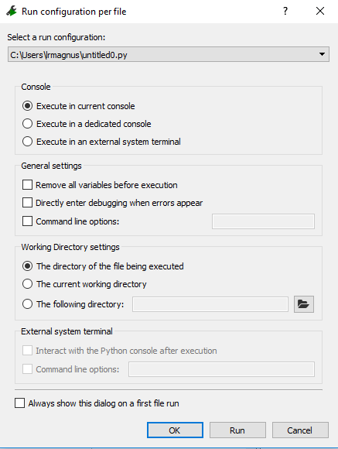

1. After clicking run, the console window will display the following prompt:

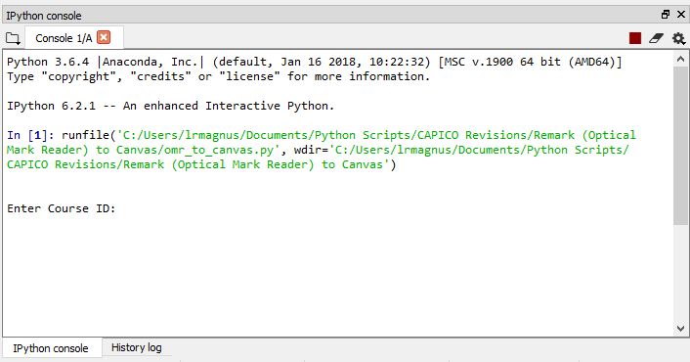

Type your course ID and then hit the Enter key to continue to the next step. After confirming your course you will need to enter yes or no for each of the following options: do you want to include student numbers, sections, and check that each student in each group is from the same section. Follow along until you see the success message that indicates the process has been completed.

## The Output

When the script has finished running a CSV file titled **CourseName***_GroupList* (unless you enter a custom name)will have been generated in the “GROUPS” folder.

## Potential Errors

While running the script, if you encounter a message in the console window saying “*Something went wrong. Perhaps you entered an invalid Canvas API Access Token or Course ID? Hit ENTER to restart the program or type 'quit' to exit:* ” it is likely that you made a mistake when entering your course ID or pasting the token into the *CanvasAPIToken* text file. Double check that these values are correct and then restart the program and try again.

## IMPORTANT

Move or rename the generated csvfiles before running the script again, otherwise the same name as an already existing csv file in the same folder can’t exist and the program will force you to choose a new name.